Apache Security: Protecting a Directory with a Password.

AuthName:This directive specifies the name that is displayed when requesting authorization to access a directory. The string specified as the value for AuthName will be what appears in the login dialog box of most browsers.
AuthName Enter your username and password
AuthUserFile: specifies the path to the file containing the list of usernames and passwords. These usernames and passwords must have been previously created using the htpasswd command.
AuthUserFile /var/secret/.members
AuthGroupFile:The same as the previous one, but with the names of the user account groups that Apache will use for authentication. It serves to organize users into groups and control their access more easily.
AuthGroupFile/var/secret/.groups
Requires user: Indicates which users in AuthUserFile have access to the directory specified in the Directory directive. The user must be listed in the file specified in the AuthUserFile directive.
Require user teresa
If we want everyone to be included, we will put
Require valid-user.
Require group: The same applies to groups. The group must be contained in the file specified by the AuthGroupFile directive.
Require group professors

Example configuration to require authentication when accessing the “private” directory
<Directory "/var/www/yourname.com/informatica/privado">
AuthName “Private access: Enter your username and password”
AuthType Basic
AuthUserFile /var/secret/.members
Require valid-user
</Directory>
GETTING IT WORKING
Example authentication using users:
- In /var/www/ we create directory “private"where we will put the protected web pages."
mkdir /var/www/private

We create the username and password file with the htpasswd command, whose syntax is:
htpasswd path_to_AuthUserFile username
(apt-get install apache2-utils to use htpasswd command)

htpasswd -c /etc/apache2/security/.users Juan

(The -c is only necessary the first time to create the file, so it is not necessary to create the file beforehand).

We see that the file (hidden) has been created and that the password is encrypted.
If we want to add more users
htpasswd /etc/apache2/security/.ana users

- In the virtual host we want to configure in /etc/apache2/sites-available, we add the following:
<VirtualHost…>
….
<Directory /var/www/private>
AuthType Basic
AuthName "Enter username and password to log in"
AuthUserFile /etc/apache2/security/.users
Requires user juan david
</Directory>
</VirtualHost>

TESTING THAT THE DIRECTORY IS PRIVATE
Be careful with this type of authentication because when you enter a valid username, it saves the data in the browser cache. Even if you leave the protected directory, you can access it again without being prompted for the password until the cache expires. For testing, it's best to use the wget command.
wget --user=”user” --password=”pass” url

EXERCISE 1 Create one directories in this path for the user ‘juan’:
- /var/www/yourname.com/informatica/private
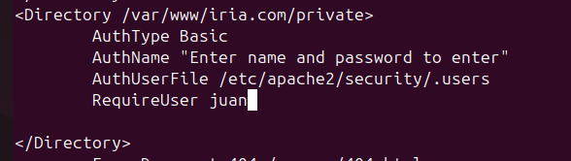
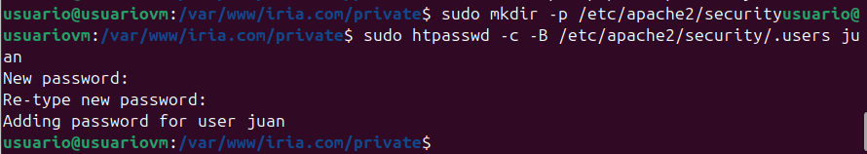

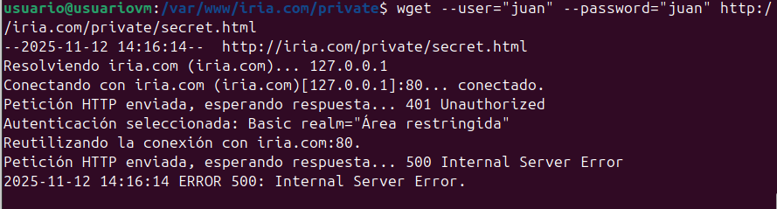

Example authentication using groups:
- Activate the corresponding module
a2enmod authz_groupfile

- We created the file .groups in /etc/apache2/security with the following format group_name: list_of_users_separated_by_spaces
Example:
Computer science: Juan Ana; Image: Teresa Carlos

- Configure host
<Directory /var/www/private>
AuthType Basic
AuthName "Enter username and password to log in"
AuthUserFile /etc/apache2/security/.users
AuthGroupFile /etc/apache2/security/.groups
Require group informatica
</Directory>

Upon logging in, if we enter a username and password of a user belonging to the IT group, it will allow access.
EXERCISE 2. Create two private directories in this path:
- /var/www/yourname.com/informática/private
- /var/www/yourname.com/image/private

Modify the virtual host configuration so that only users belonging to the corresponding group can access each of the two directories. Can a user belong to more than one group?

Please take a screenshot of the changes made to the configuration file.

Please include a screenshot showing the successful completion of the test (both user groups). Don’t forget to use WGET for testing.

